

**FACULTY: INFORMATION TECHNOLOGY**

**DEPARTMENT: SOFTWARE ENGINEERING**

**RESERCH PROJECT PROPOSAL**

**TOPIC: DIGITAL AUCASA ACTIVITIES MANAGEMENT SYSTEM**

**Proposed by:**

**Names:** KABERA Christian

**ID**: 23025

**Phone:** +250780362030

**Email:** [chrisskabera5@gmail.com](mailto:chrisskabera5@gmail.com)

**PART I**

**INTRODUCTION OF CURRENT SYSTEM ENVIRONMENT**

1. **BACKGROUND OF THE STUDY**

In AUCA, Students has an association that is responsible of looking after other students and their profit in both campuses MASORO and GISHUSHU. The mentioned association is called AUCASA and is composed by eight leaders who expires after one year mandate. The team is led by guild president whom others report to. After him, there are two vice presidents one for MASORO and other for GISHUSHU campus. Below them, there are four ministers. One for communication, another for gender and protocol, next for sport, lastly one for social affairs. Last, there is treasurer for managing finance.

AUCASA has been serving students years and years, even now their duties of serving is ongoing. There are different activities that AUCASA does in their mandate. On top, they communicate necessary information from school administration to students and vice versa. They are also in charge of listening and solving to problems of students with the school support. Not only communicating but also they host many events and games like, football and basketball matches, cultural events and so many others.

In September 2021 I was voted as Minister of Information for both campuses MASORO and GISHUSHU. I served the whole year on duties. I was using different WhatsApp groups to share the information which students always complain that it is not a good mean for them. Some do not belong to any group, other do not read due to heavy chats, others use it for insulting others. On other hand, AUCASA leaders also struggles for recording the students problems and their activities even making report is not that easy as there is no mean for that.

As inspired student but also a leader, I thought about the system that will help my fellow AUCASA leaders to record students’ problems, activities and plan. AUCA students at large will use the system as page that they will be visiting and know the necessary information and opportunities around. Importantly, they will be able to ask questions and problems they have on the system.

1. **MISSION**

Provide Christ-centered holistic quality education to prepare for service in this world, and in the life to come.

1. **VISION**

Become an international center of academic learning with global impact.

**PART II**

**AS-IS-PROCESS MODEL**

1. **Description of the current system**

The current system, they record manually in papers that may disappear anytime. There is no efficient way to listen to students who did not make it to come to office. In communication, some events surprises students which kill their schedule. In addition There is no way of decision making based on facts and report of previous occasions.

1. **Actors**

* Students
* Aucasa Leaders

1. **Modeling the Current System**

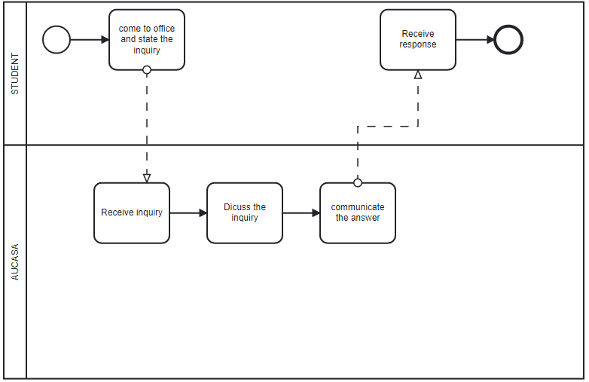

**PARTIII**

**PROBLEM OF THE CURRENT SYSTEM**

**• Performance** - The need to improve performance

1. Throughput: uses of phone calls and papers.

2. Response Time: It took about a more than 24 hours to respond students’ inquiry.

**• Information (and Data) - The need to improve information**

1. Input: there need a change how the information is received.

2. Output: there need a change how the information is responded.

3. Storage: need usage of databases not papers.

**• Economics - The need to improve economics, control costs or**

**Increase profits**

1. Profit: money spend in ticket and airtime will be saved.

**• Control (and Security) - The need to control and Security**

1. Too little security or Control

**• Efficiency - The need to improve efficiency of people and process**

1. People

2. Machines

3. Computers

**• Service – The need to improve services**

1. The system produces inaccurate results

2. The system produces inconsistent results

3. The system produces unreliable results

4. The system is not easy to learn

5. The system is inflexible to new or exceptional situations

6. The system is not coordinated with other systems

**PART IV**

**TO-BE-PROCESS MODEL**

1. **Main module of the new system**

* **User**
* **Create account** 
  + - **Input:** A user creates an account with full profile
    - **Process:** The application processes user requests, checks provided information and save them.
    - **Output:** Notify if all saved or failed.
* **User login to the system**
  + - **Input:** User provides his or her credentials to the system
    - **Process:** The application processes the user request by checking if credentials provided match with those saved.
    - **Output:** Notify if username or password are not matching and when are marching will enable user to login into the system.
* **Submit question**
* **Input:** User writea description his/her question of in text field.
* **Process:** The system submit the inquiry of the user to the database.
* **Output:** System uploads information regarding the inquiry.
* **User logout from the system**
* **Input:** Logout query sent to the system by user.
* **Process:** The system processes the user request.
* **Output:** Logout notification appeared.
* **Admin**

**Update the system**

* **Input:** Modification to the system done.
* **Process:** The system checks if modification done is valid and then be modified.
* **Output:** The message will be returned if changes were successfully updated.

1. **TO-BE Processed model**

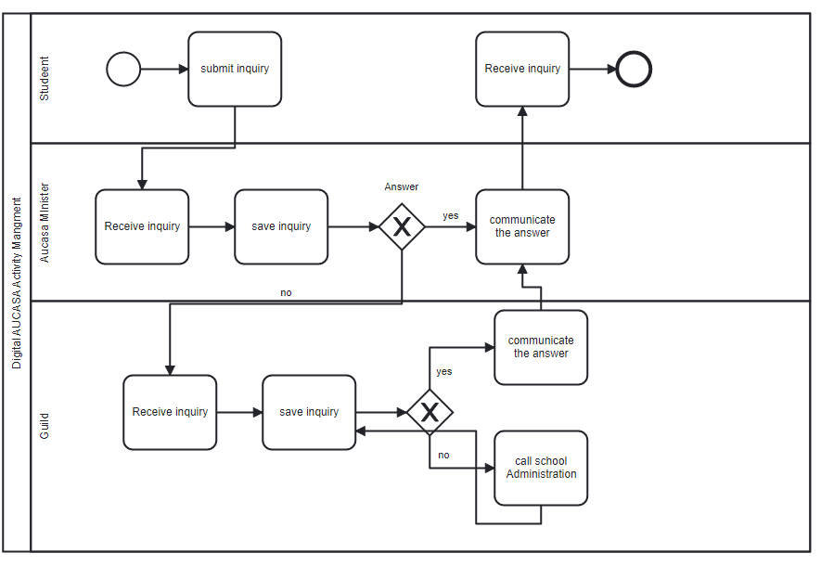

**PART V.**

**REQUIREMENTS ELICITATION**

**1.** **FUNCTIONAL REQUIREMENTS FOR THE PROPOSED SOLUTION**

* The system shall allow new user (AUCASA leader) to create an account.
* The system shall allow existing user to login into the system.
* The system shall allow the administrator to login into the system as an admin.
* The system shall be able to differentiate user’s and administrator’s responsibilities
* The AUCASA leader shall be able to record, update, delete, and view the past records regarding his/her case for one only at his serving desk or not any leader who is not concerned
* The AUCASA leader shall be able to change his or her credentials
* Administrator shall be able to change his or her credentials
* All users shall be able to logout from the system

**2. NON-FUCTIONAL REQUREMENTS FOR THE PROPOSED SOLUTION**

* **Security:**
* The system shall be able to hide the users’ information.
* The system shall provide right privileges according to user type.
* Only Administration shall view all records from all country.
* Only a user’s username and password matches shall be able to login.
* **Maintainability:**
* The system shall be easy to be maintained, when it happens to be maintained.
* **User friendly:**
* The system shall be user friendly.
* The system shall be easy for a user to learn it and understand the use of it.
* **Operational:**
* The system shall be able to run on any OS.
* The system shall perform user requests not beyond 10 seconds in performance.
* The system shouldn’t exceed 20 secs performance in case of downtime.
* The system shall be running for 24 hours a day.
* **Accessibility:**
* The system shall be accessible via laptop or other programmed. Electronic device such as phones and tablets.
* The system shall be available online to everyone who needs it.
* The system processes shall be accessible by all authorized people.
* **Availability:**
* The system shall not have unexpected downtime.
* The system shall have downtime at most 120 min/week.
* **Storage:**
* The system shall storing recorded data in database.

**PART VI.**

**TOOLS AND TECHNOLOGIES TO BE USED IN PROPOSED SYSTEM**

**Operating System:** Any Operating System

**Programming language:** Java programming language, Python, JavaScript, CSS, HTML

**DBMS:** MySQL-Server, neo4j

**IDE & Text editor:** Eclipse, Visual Studio Code,

**Tools of designing models:** Enterprise architecture, Visual Paradigm.

**PARTVII.**

**PROJECT PLAN AND SCHEDURE**

|  |  |  |  |  |  |
| --- | --- | --- | --- | --- | --- |
| **S/N** | **Activities** | **DEC** | **JAN** | **FEB** | **MATCH** |
| **1** | **Chap 1&2** |  |  |  |  |
| **2.** | **Chap 3&4** |  |  |  |  |
| **3.** | **Chap 5&6** |  |  |  |  |
| **4.** | **Submit Book** |  |  |  |  |
|  |  |  |  |  |  |